LAB 7.3
Task 1: Paste a function with a missing colon (add(a, b)), and let AI fix the syntax error.
ERROR
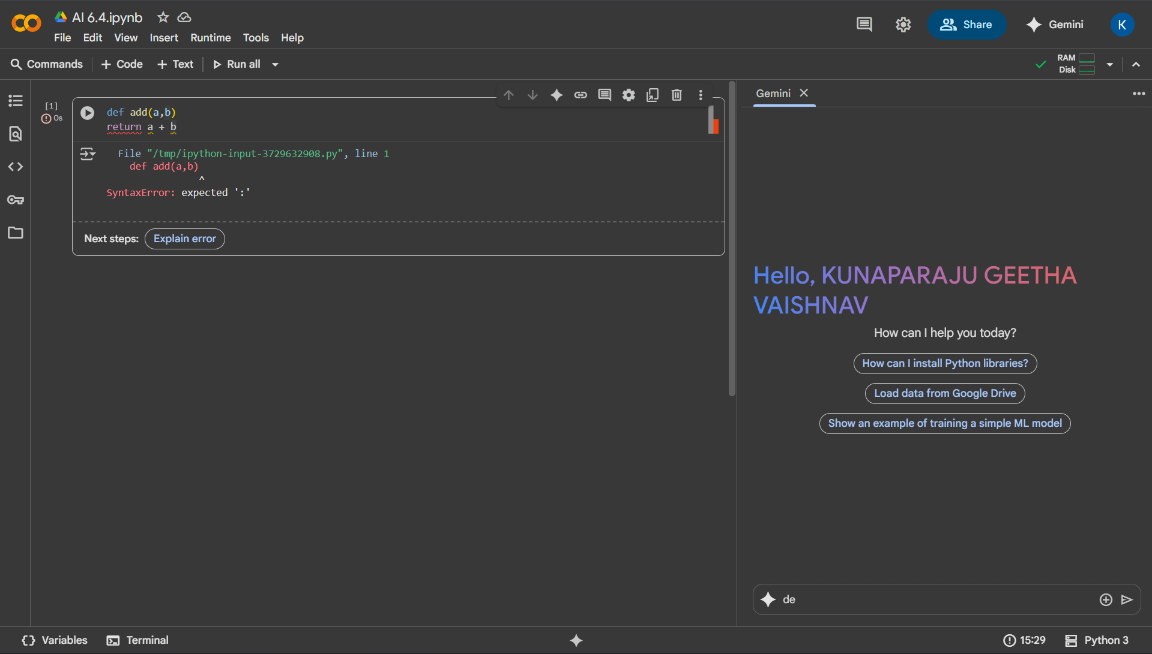
CORRECT
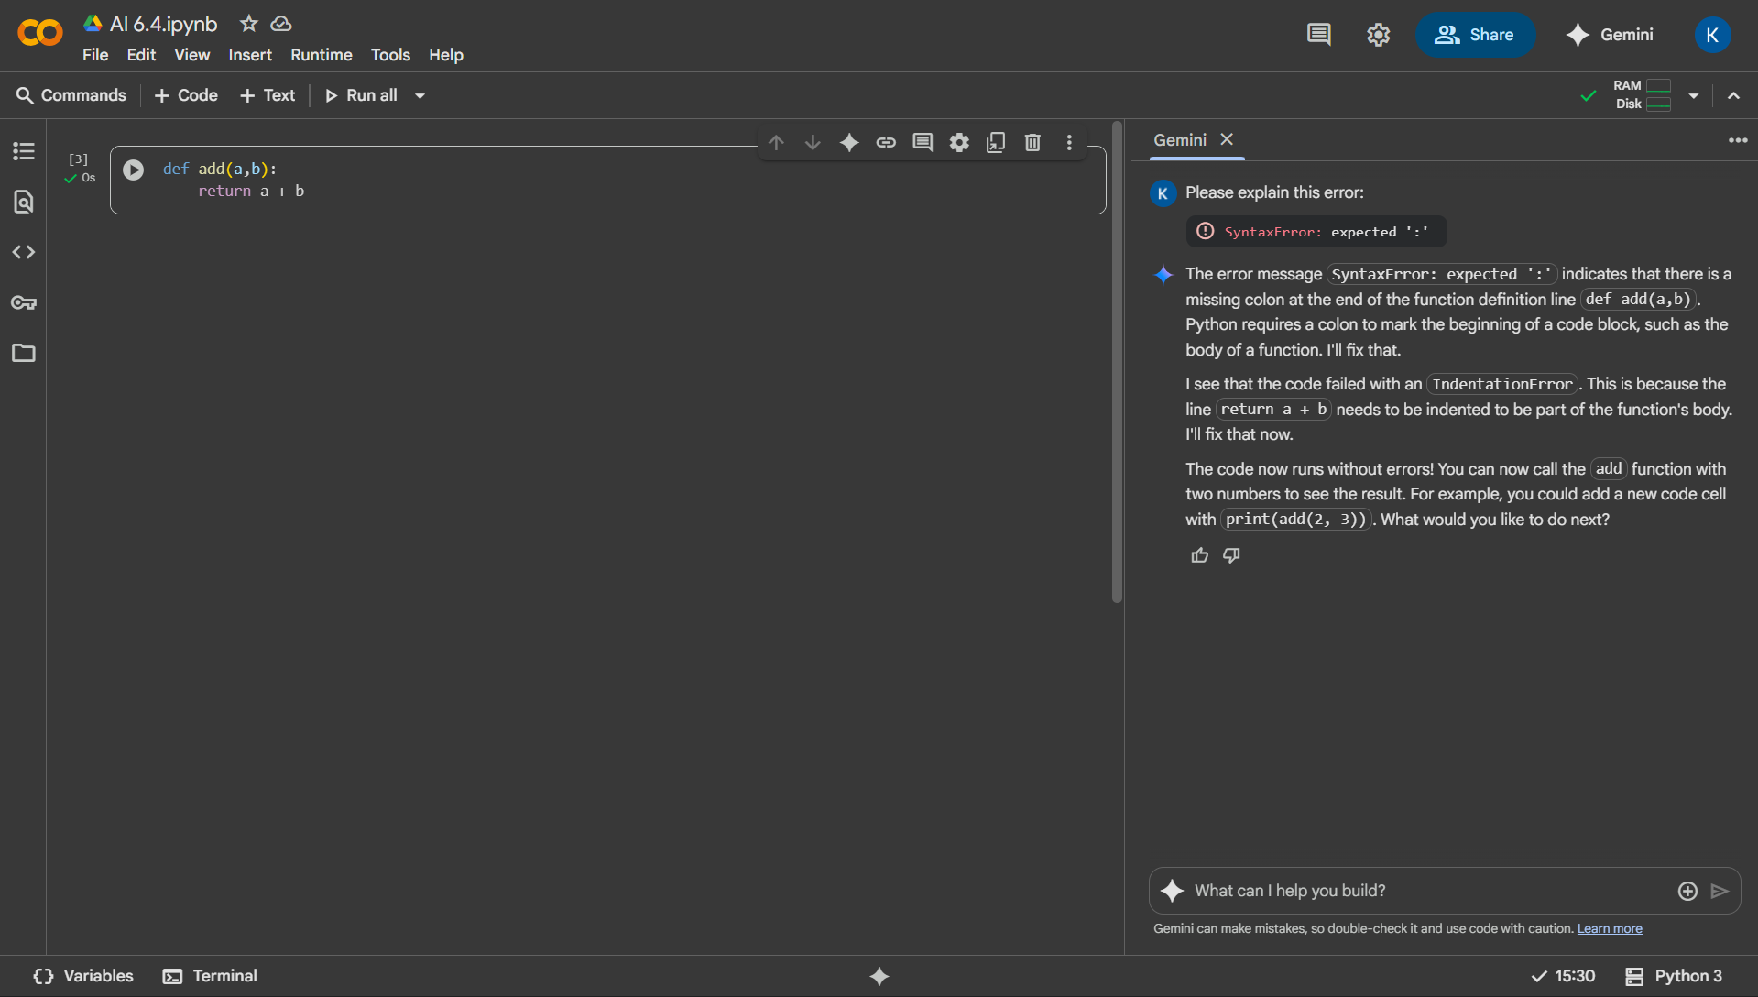

Task 2: Identify and fix a logic error in a loop that causes infinite iteration.
ERROR
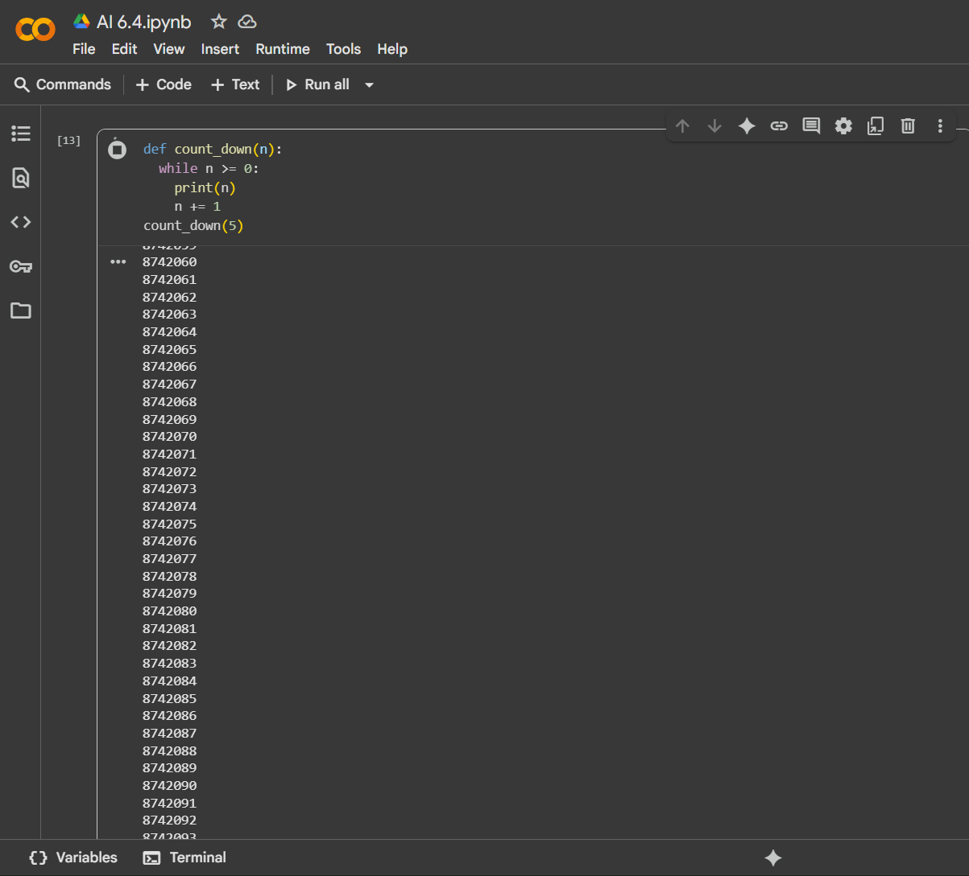
CORRECT
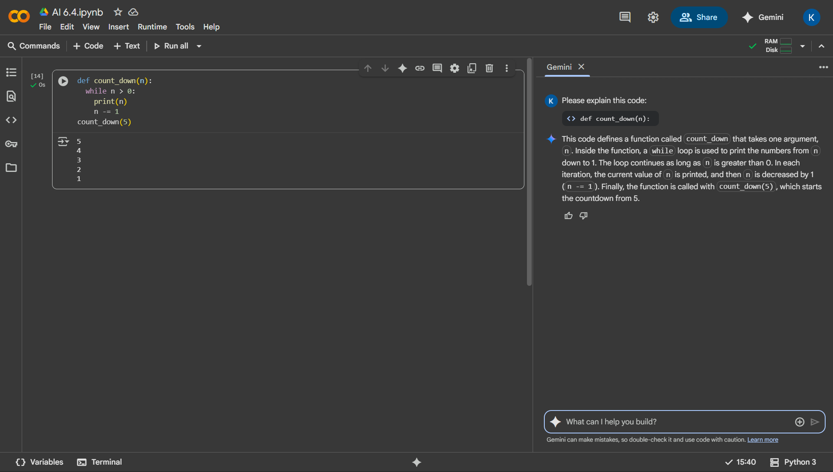

Task 3: Debug a runtime error caused by division by zero. Let AI insert try-except
ERROR
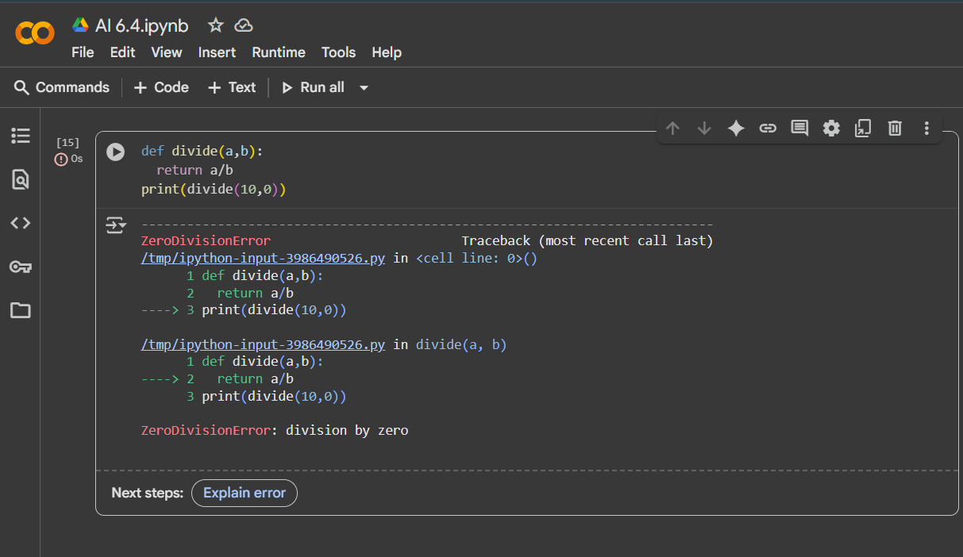
CORRECT
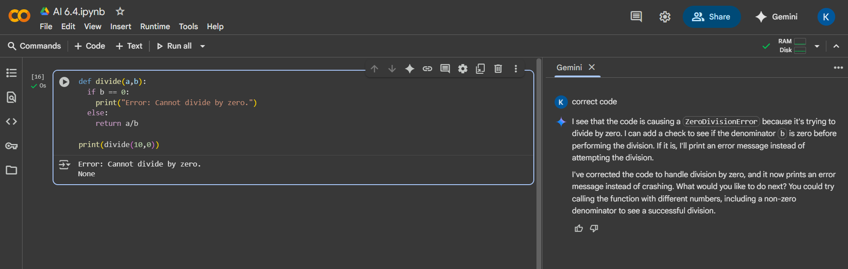

Task 4: Provide a faulty class definition (missing self in parameters). Let AI fix it
ERROR
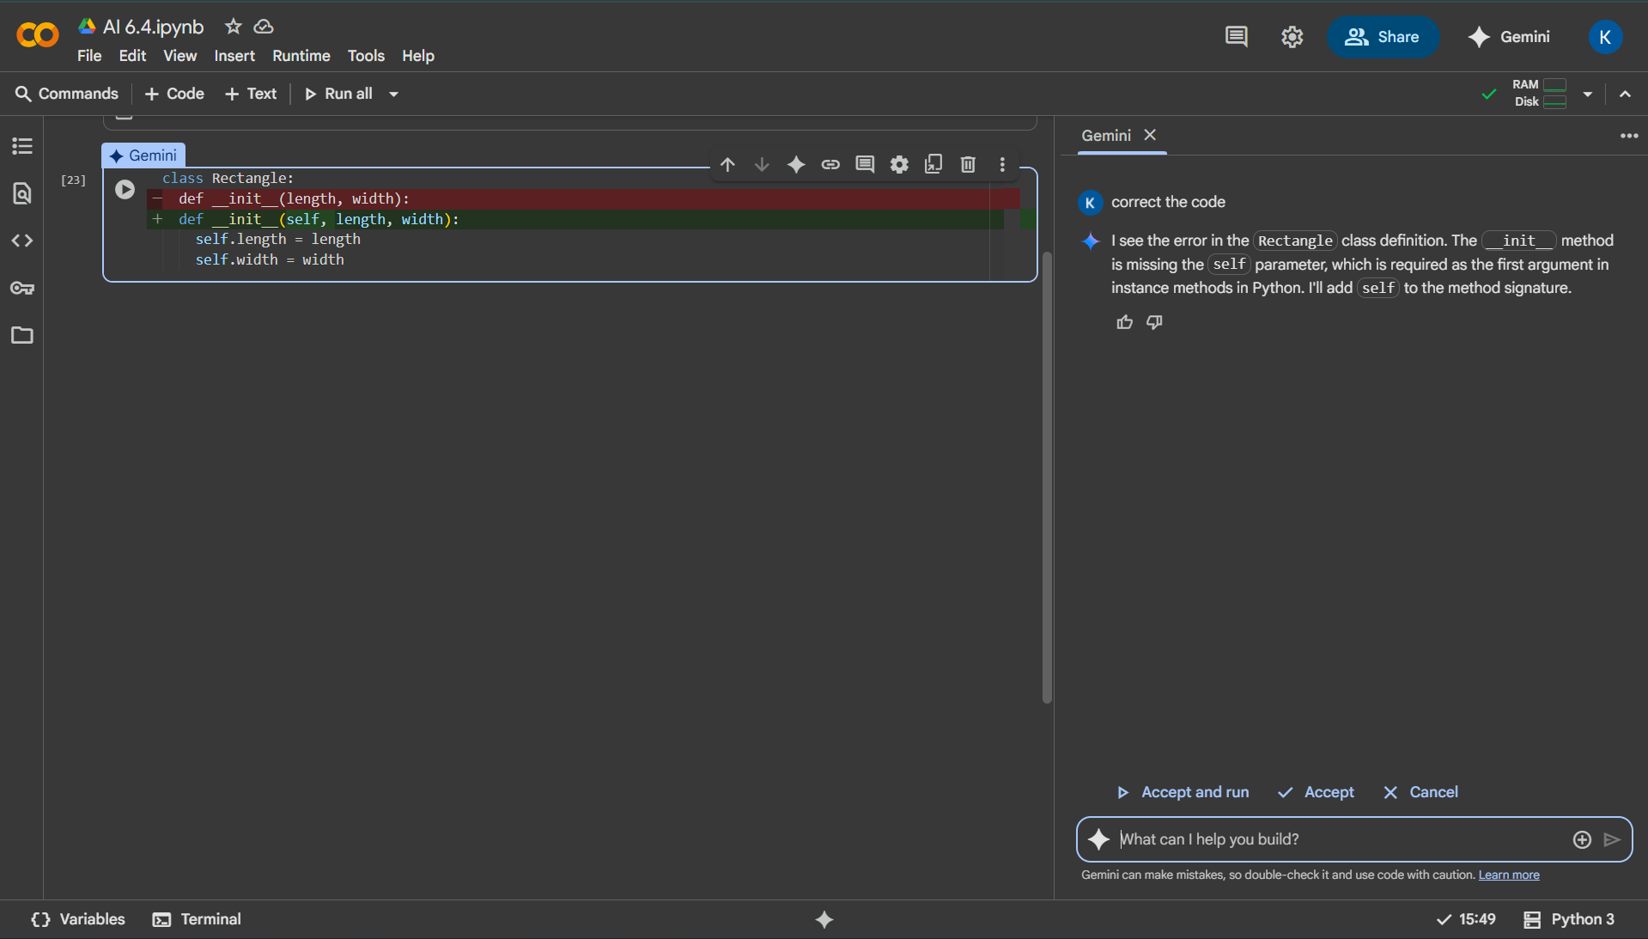
CORRECT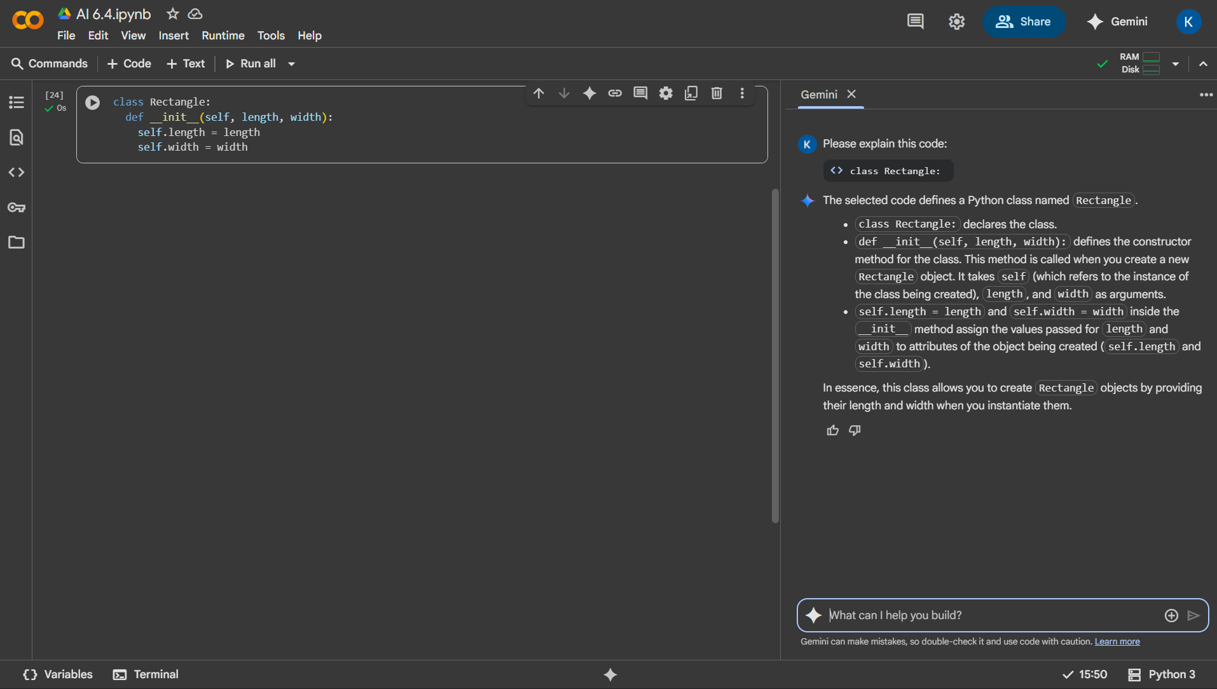

Task 5: Access an invalid list index and use AI to resolve the Index Error.
ERROR
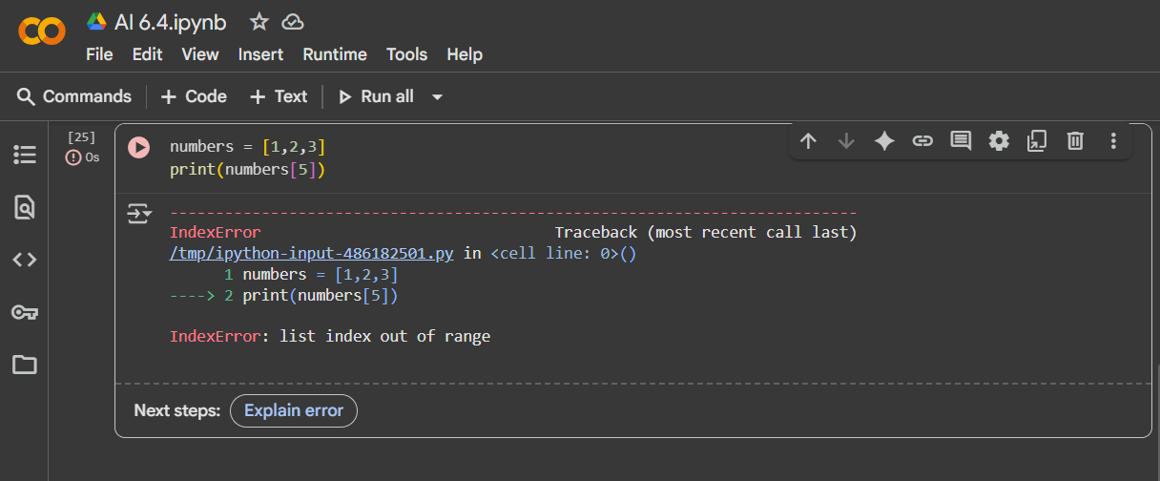
CORRECT
